PUBLIC TRANSPORTATION OPTIMIZATION

Team members

PHASE 3 SUBMISSION DOCUMENT

622621121032:E.MUTHULAKSHMI

TOPIC-IOT BASED SMART PUBLIC TRANSPORT BUS

INTRODUCTION:

With the increasing population in city, cities are facing a difference range of issue such as suffer traffic fully air quality, increasing road accidents, and burst growth in number of private vehicle. And the same time decreasing share of public transport. With the development of Information technology, Internet of Things is becoming reality. IoT can assist in the co-ordinate of communication, control and information processing present in the public transport system.The inspiration for this project was to limit and curtail the difficulties and issues related with public transport framework in India. India is a developing country. Here, we face many issues in our daily life. Citizens who use local travel in day-to-day life, local travels don’t show exact timing of bus and numbers of passengers in the bus. We developed a project with GPS system for exact location of bus and develop a circuit for count the number of passengers in the bus. The passenger simply scans the QR code which is placed in every bus stop and they get bus details in webpage. It is helpful for passenger like students and job employee. They can use it to arrive in time. As well as using the website passenger can see where the bus is how many passengers are present in bus and how long it will take for the bus to reach there.[1]These are helpful in daily to develop, such as traffic congestions, unexpected delays, irregular vehicle dispatching time, other happens. It provides more easily with publics and provide exactly time and bus location so that they may not get late. The proposed system requires a ellipse that is open source software environment. The IDE is used in android development in order to make it quick. This platform is multitasking. It is useful for workers and students.

METHODOLOGY:The system is placed in every bus the system built around Arduino nano. When system turns on, the LCD and

GSM Module is initialized. The GSM module is used to accessed wireless internet in the bus. GPS is used to get the latitude and longitude that is exact position of bus. Arduino reads the position continuously. Ignition is checked. If ignition is on then the GPS co-ordinates that is latitude and longitude are read by Arduino nano. Arduino nano sends GPS co-ordinates, passenger count to webpage. IR sensors are placed at the entry and exit doors of bus to count the number of passengers in bus. If ignition is off then output of IR sensors at the entry and at exit is sensed by Arduino nano. If the IR sensor at the entry, senses passenger then Arduino nano increments passenger count by 1. Arduino sends all these details of bus continuously to a webpage through internet connection the web page also contains the details of bus like bus number, bus route, bus timing which is manually uploaded by authority. Public access all these details of bus on visiting to that particular web page. For simplicity to access webpage, the QR code of link of webpage is attached to every bus stop.

LITERATURE SURVEY:

In past works given in SeokJuLee[1], they have actualized transport vehicle tracking for UCSI University, kuala Lumpur, Malaysia. It is developed for settled course, giving the candidates with status of bus after determined time period utilizing LED panel smart phone application. Technique used is Ardunio microcontroller Atmega328 based Arduino UNOR3 microcontroller. GPS, GSM or GPRS module a similar controller is used. Program to control them is composed in C programming language, compiled and saved in microcontroller's flash memory. The testing results in this paper give; testing in-vehicle module, testing web server and database, testing smart phone app. In PengfeiZhou[2], foreseeing transport entry time with cell phones is given. Innovation utilized is participatory detecting of users. This model framework with various sorts of Android based cell phones and thoroughly explores different avenues regarding the NTU grounds carry transports and in addition Singapore transports over a 7-week time span, then taken after by London in 4-weeks. The proposed framework is arrangement is all the more for the most part accessible and is vitality agreeable. The assessment comes about recommend that the proposed framework accomplishes extraordinary expectation exactness contrasted and those operator initiated and GPS based solutions. The model framework predicts transport entry time with average tolerance of 80 sec. In Maman Abdurohman[3], versatile tracking framework is utilized to monitor vehicles position and in uncommon cases there are much helpful data can be studied, for example, speed, cabin temperature and no. of passenger. This monitoring procedure is done utilizing GPS module, and sending the information to a server through GSM modem. It is proposed machine to machine communication from which Open Machine Type Communication as correspondence platform for collecting and preparing area information. The google outline shows the area. The Open MTC platform that is produced by Fraunhofer FOKUS in view of ETSI M2M Rel.1 specification.

MODELING AND DESIGING: Waterfall model control the system. Schedule is set for deadlines all stages of development and projects can process by using the development process model stage one by one.Requirement Gathering and Analysis: -The passible requirement of system is developed in phase. In our project there are two types of requirements namely hardware and software requirements. Firstly, the connection between GSM module and webpage should be established. This connectivity will take place through internet. To establish this connectivity, required commands are sent to GSM module by the controller. Hence, TCP connection with UBIDOTS server is linked. ➢ Once the proposed required of our system TCP connection is linked, it is analyzed and used to send the data to webpage.

System Design: - The specifications from the first phase are studied in this phase and the system design is prepared. Specifically, DFD (Data Flow Diagram), architectural design, block design and use case design of our system is prepared which helps to specify hardware and software requirement and helps in defining the overall system infrastructure.

DFD (Data Flow Diagram): - Signifies the exact flow of data in the system.

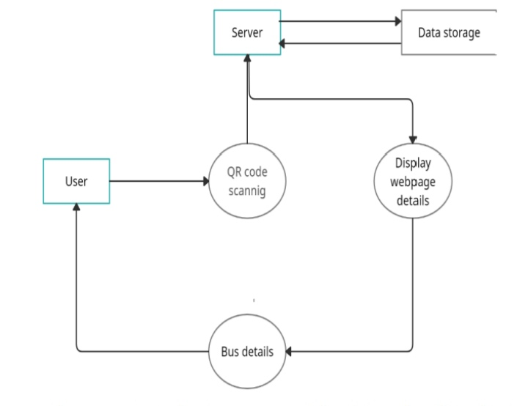

This is the Data flow diagram of our project, first user scans the QR code after that request sends to the server access the data from cloud then the server displays the whole details of bus, that is route of the bus, real time location of bus, bus number and exact count the number of passenger in bus.Architecture design: - It makes the architecture of system understandable.

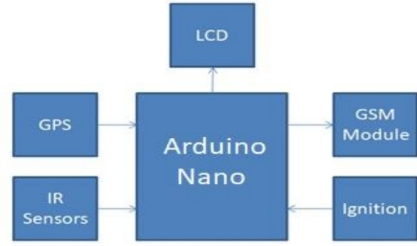

LOADING AND PRE PROCESSING THE DATASET FOR PUBLIC TRANSPORTATIONTRANSPORTATION:

To load and preprocess the dataset for public transport privatization in bus, you can follow these steps:

Load the dataset.

This can be done using a variety of tools and libraries, depending on the programming language you are using. For example, in Python, you can use the pandas library to load the dataset from a CSV file.

Python:

import pandas as pd

# Load the dataset

df = pd.read_csv('public_transport_privatization.csv')

Use code with caution. Learn more

Inspect the dataset:

Once the dataset is loaded, you should inspect it to get an understanding of the data types, the number of rows and columns, and any missing values. You can use the df.info() function to get a summary of the dataset:

Python:

# Inspect the dataset

df.info()

Use code with caution. Learn more

Clean the dataset.

Any missing values or errors in the dataset should be cleaned before you can use it for analysis. For example, you can use the df.dropna() function to drop rows with missing values:

Python:

# Drop rows with missing values

df = df.dropna()

Use code with caution. Learn more

Encode categorical variables.

If the dataset contains categorical variables, such as the type of bus service or the ownership of the bus company, you will need to encode them before you can use them for analysis. This can be done using a variety of methods, such as one-hot encoding or label encoding.

Split the dataset into training and test sets. Once the dataset is cleaned and encoded, you should split it into training and test sets. This will allow you to evaluate the performance of your model on unseen data. You can use the train_test_split() function in scikit-learn to split the dataset:

Python:

from sklearn.model_selection import train_test_split

# Split the dataset into training and test sets

X_train, X_test, y_train, y_test = train_test_split(

df.drop('outcome', axis=1),

df['outcome'],

test_size=0.25,

random_state=42

)

Use code with caution.

Preprocess the features.

Depending on the machine learning algorithm you are using, you may need to preprocess the features before you can train your model. For example, you may need to scale the features or normalize them.

Once the dataset is loaded, preprocessed, and split into training and test sets, you are ready to train your machine learning model.

DATA SET:

|  |  |
| --- | --- |
| No.  1  2  34 567 8 9 10  11  12 1314 15 16 17 1819 20  21 22 23 24 25 26 27 28 29  30 3132 33 34 35 36 37 38 | Data information  Card ID∗  Transaction ID∗ Mode codeLine ID∗  Name of the transitline  Vehicle IDVehicle number Boarding station ID∗ Alighting station ID∗ Name of boarding stationName of alighting stationBoarding (tap-in) time∗Alighting (tap-out) time∗ Number of transfer Total travel distanceTotal travel time∗Boarding fare Alighting fare,e number of usersBoarding violation penalty Alighting violation penaltyGeneral user codeStudent user codeChild user codeOther user codeUser division27 User groupCompany code Company nameTime code Starting run timeEnding run timeBoarding dateAlighting date Year Zone code Transfer station ID Transfer time |

The Data Analysis Tool for Urban Transport is a simple Excel-based tool that enables users to compare several urban transport related indicators in a city with similar indicators in peer cities. Such a comparison would allow users to identify areas where the city under study is performing well or is performing poorly. The tool has been developed using a database on urban transport covering over 93 cities with data collected only from secondary sources. The output is a report presenting how the city is performing vis-a-vis peer cities with respect to a set of performance indicators. The tool aims to provide a comparative framework for urban transport experts so that they can better identify the main deficiencies in the city’s transport system and recommend the most appropriate remedial measures. The idea is to get a report that would be something like a pathologists report helping a doctor better identify the patient’s ailment.

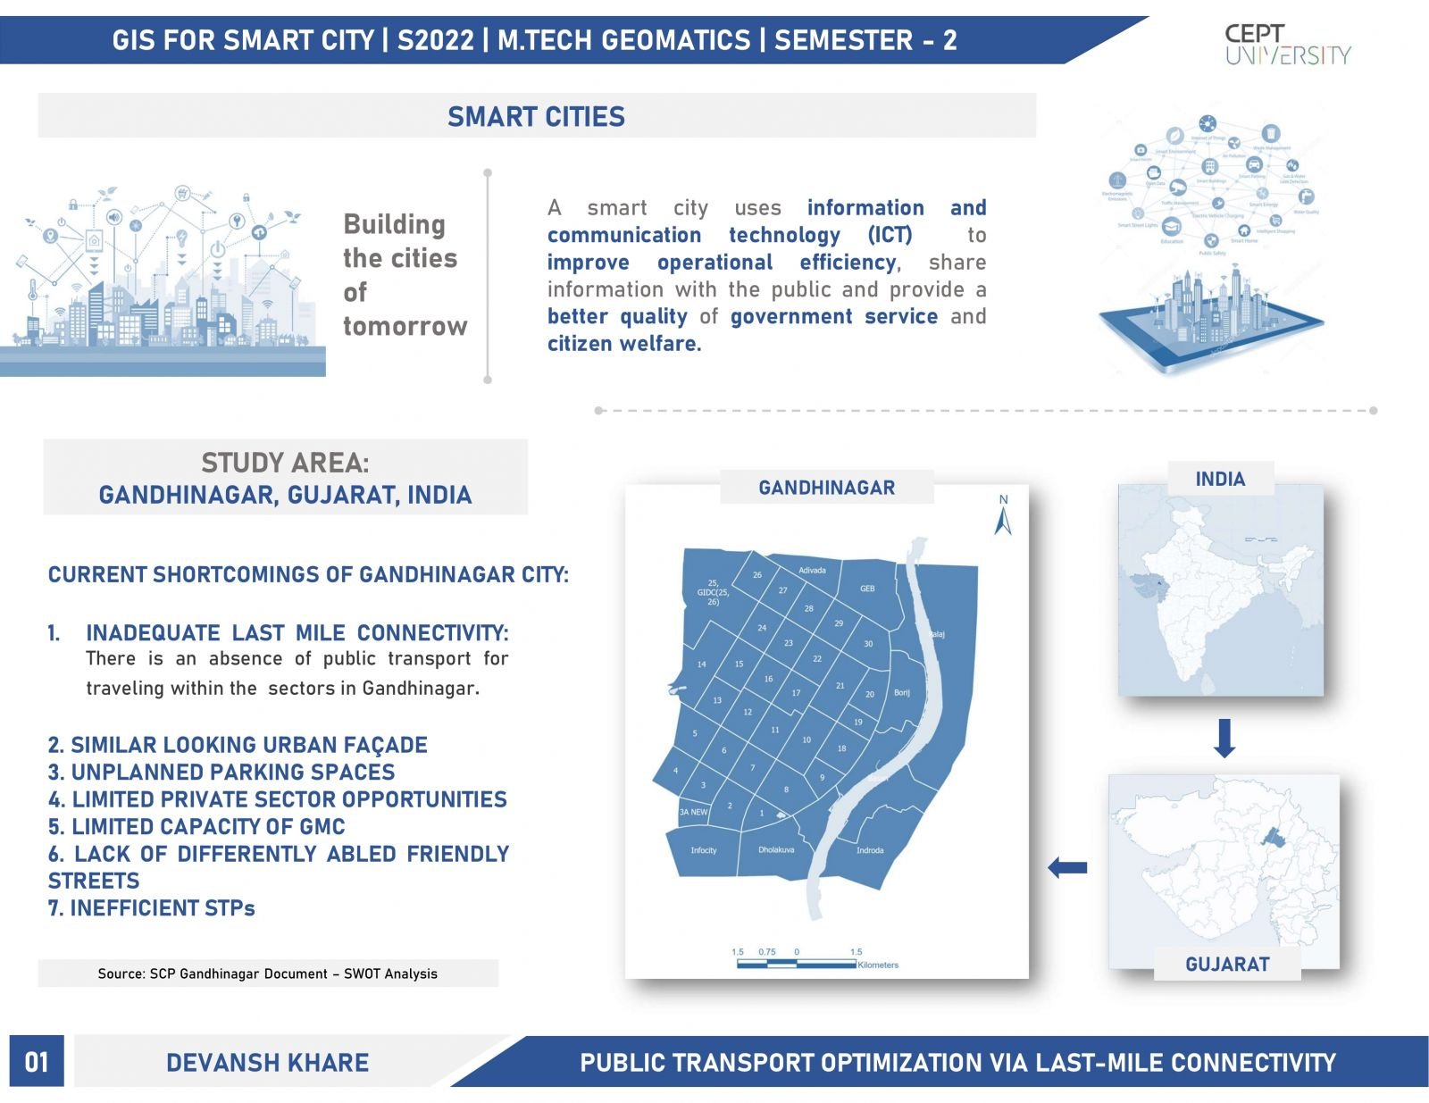

Creating a program for public transport optimization using a dataset would typically involve various steps and might require specific tools or programming languages. Here's a high-level outline of the process:

1. **Data Collection:** Obtain a public transport dataset that includes information on routes, schedules, stops, passenger demand, and other relevant details. You can use sources mentioned earlier like data.gov or Kaggle.

2. **Data Preprocessing:** Clean and prepare the dataset by handling missing values, formatting data, and ensuring consistency. You may need to convert the data into a usable format, such as CSV or JSON.

3. **Analysis and Modeling:** Depending on your optimization goal (e.g., minimizing travel time, cost, or maximizing passenger satisfaction), you'll need to choose an appropriate optimization algorithm. Common approaches include linear programming, genetic algorithms, or graph-based algorithms. Implement the chosen algorithm using a programming language like Python.

4. **Optimization Parameters:** Tune and configure your optimization model with relevant parameters, such as constraints, objectives, and optimization functions.

5. **Solver or Optimization Library:** You might need to use an optimization solver or library like Gurobi, PuLP, or scipy.optimize in Python to solve the optimization problem.

6. **Visualization:** Create visualizations to represent the optimized public transport system, such as route maps, schedules, and performance metrics.

7. **Testing and Validation:** Test your optimization program with real or simulated data to ensure it meets the desired goals and constraints.

8. **Deployment:** If the optimization program works as expected, you can deploy it to assist with real-world public transport optimization decisions.

Smart City Public Transport Case in Point: Singapore:

With minimal land area and a growing population, Singapore’s government knew that transportation was becoming a bigger and bigger issue. As such, The Smart Nation Initiative has “transport” as a core focus area.

Singapore had rolled out the worlds first congestion based road usage pricing system – Electronic Road Pricing (ERP) – decades ago, but as a key smart nation initiative, the Land Transport Authority (LTA) of Singapore is now rolling out the Next Gen ERP system with IoT and event-driven architecture at its core. In this system, vehicles are equipped with onboard devices that leverage GPS to transmit real-time position, speed, and more. With this information, the LTA is able to implement real-time road tolling as well as finer-grained road pricing. Drivers are also able to receive real-time alerts to notify them of congestion, as well as suggestions of alternate routes to avoid tolling.Bringing it back to average road speed for a second, it should be noted that Singapore is now one of the least congested major cities, with an average vehicle speed of 27km/h on main roads (compare this to 16km/h in London).In 2020, the ITS system will extend to Singapore’s large bus fleet. The city plans to introduce autonomous buses that will reduce passenger density and improve bus punctuality.

Conclusion:

In addition, public transportation's vehicles are able to move faster in special roads that cause of decreasing traffic on the streets. Also, the noise from traffic would reduce through expanding buses system, trains system, and subways system.

Advantages of optimisation methods include the reduction of costs of transport charges, storage or production processes. Besides an economic merit of the optimisation process there also increases the efficiency of time needed for logistic operations execution.

, environmentally friendly transportation methods are those which have a low impact on the environment. Many countries have taken measures to address environmental problems through processes and infrastructure, which can be shown in cities such as Oslo, London and Amsterdam.

The desired result is a society where living conditions and resources meet human needs without undermining the planetary integrity and stability of the natural system.

Sustainable development tries to find a balance between economic development, environmental protection, and social well-being.